ATTENDANCE SYSTEM IMPLEMENTATION USING RFID

AIM:
The main aim of the project is to develop the attendance system using RFID technology.

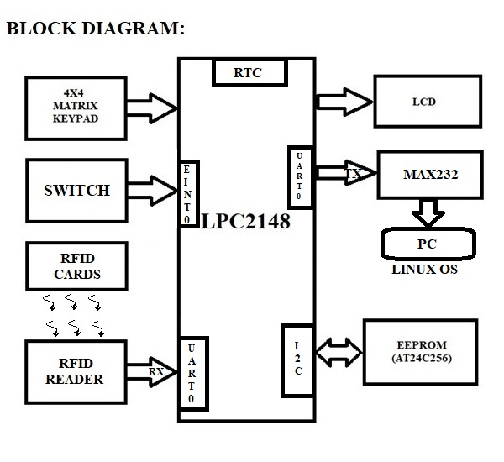

REQUIREMENTS:
HARDWRAE REQUIREMENTS:
- LPC2148
- RFID READER
- RFID CARDS
- LCD
- EEPROM (AT24C256)
- 4X4 KEYPAD
- MAX232
- BUZZER
- USB-TO-UART CONVERTER

SOFTWARE REQUIREMENTS:
- EMBEDDED C – PROGRAMMING
- KEIL-C COMPILER
- FLASH MAGIC

Steps to be followed to complete your project:
- Create New Folder in your server save that folder with your project name
- Copy what you done files like lcd.c, lcd.h, delay,c, delay.h, uart.c, uart.h, keypad.c, keypad.h, i2c.c and i2c.h into project folder.
- Individually can check each and every module.
- First check lcd to display character constant, string constant and integer constant.
- Next check keypad peripheral by displaying key values on LCD.
- Next write n bytes into EEPROM and read that n number of bytes from EEPROM and display on LCD.
Note: Use BYTE WRITE and BYTE READ functions or PAGE WRITE and PAGE READ functions
- Next check the on-chip RTC working code and display on RTC information on LCD.
- Next check uart peripheral by transmitting character constant, string constant and receive
string constant using hyper terminal. (Note: use uart interrupt concept)
- Connect RFID READER D0 pin to USB to UART converter and test the working condition.
- Then write logic for reading the card number and display it on LCD.
- If above steps are completed create new file with projectmain.c, add all peripheral definition files, and write below steps in projectmain.c file
- First store three cards information in the code memory and assign the user names for each card.
- And inside main function, initialize all peripherals.
- In the continuous process, main application program is waiting for RFID card. If user placed the RFID card, then application program is checking whether placed card is valid or not. If it is valid card, then read the EEPROM information related to this user about current entry is belongs to IN/OUT. First time entry is treated as IN and second entry is treated as OUT. In and OUT status of each user need to save in the EEPROM. After processing, display the IN/OUT status along with current time on LCD as well as send the same information in proper format to the system through seral communication.
- If user want to change the RTC information, he/she has to generate the interrupt by pressing switch which is connected to interrupt pin. If interrupt is occurred, then stop the current process and display the menu for RTC editing. Then based on user requirement, user has to select and change that particular timing information and update that latest value into equivalent timing SFR.
- LINUX CODE WORKING: First download the UART_LOOPBACK_CODE_FOR_LINUX code from LMS card under reference programs and check the working of that code on Linux system. After checking, continuously read the com port data which was updated by the controller, and update the attendance of each entry into the excel sheet in the below mentioned format.
User name – status (IN/OUT) – Time - Date
- If you’re getting this output then your project is completed.

Note: if same application is completed for more than one user, it is more effective/impressive.
********************************ALL THE BEST **********************************

RFID READER: RFID Reader will send the 10 bytes of data once card is placed nearer to the RFID Reader. Once check the below images to get some idea on RFID Reader block diagram. Refer the supported data sheets to get some more knowledge.

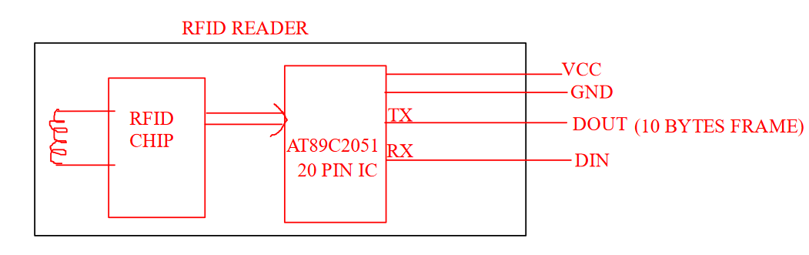

For example, card number is 12345678, then output of the RFID Reader is
0x02 0x31 0x32 0x33 0x34 0x35 0x36 0x37 0x38 0x03 (hex format)

